**********************CSS CONCEPT******************

🡺way to add fonawsome :

Step 1 :go to cdn link of font awesome then import it

Step 2 : add your font awesome

🡺way to add font awesome in ::after or ::before

 .watch::before{

*content*:'\f06e';

*font-family*: fontAwesome;

        }

Skeleton loading :

1.for images :

 .skeleton{

*animation*: skeleton-loading 1s linear infinite alternate;

        }

        @keyframes *skeleton-loading*{

            0%{

*background-color*: hsl(200,20%,70%);

            }

            100%{

*background-color*: hsl(200,20%,95%);

            }

        }

2.for line

.skeleton-text{

*width*: 100%;

*height*: 1rem;

*margin-bottom*: 0.5rem;

        }

        .skeleton-text::last-child{

*margin-bottom*: 0;

*width*: 80%;

        }

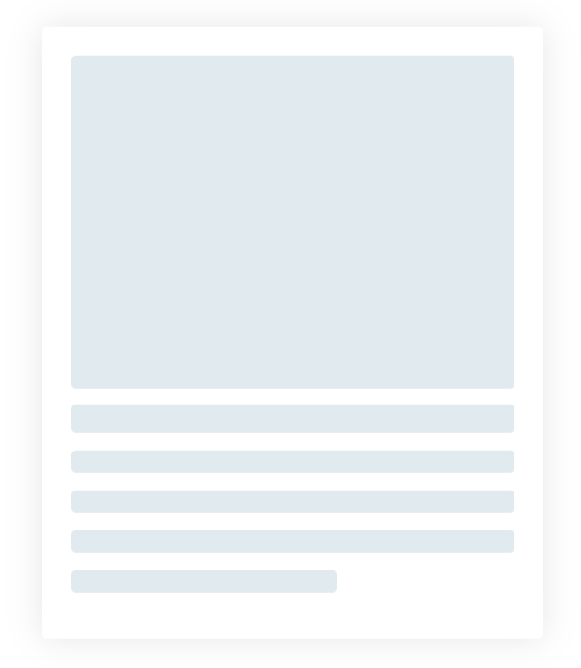

<!DOCTYPE html>

<html lang="en">

<head>

    <meta charset="UTF-8">

    <meta http-equiv="X-UA-Compatible" content="IE=edge">

    <meta name="viewport" content="width=device-width, initial-scale=1.0">

    <title>Document</title>

    <style>

        body {

*display*: flex;

*justify-content*: center;

*align-items*: center;

*min-height*: 100vh;

        }

        .skeleton-animation {

*animation*: skeleton 1s infinite alternate linear;

        }

        @keyframes *skeleton* {

            0% {

*background*: hsl(201, 35%, 90%);

            }

            100% {

*background*: hsl(200, 20%, 95%);

            }

        }

        .card {

*width*: 400px;

*height*: 500px;

*border*: 1px #fff solid;

*box-shadow*: 0 0 30px rgba(0, 0, 0, 0.1);

*border-radius*: 5px;

*padding*: 25px;

        }

        .img {

*width*: 100%;

*height*: 300px;

*border-radius*: 4px;

        }

        .heading {

*height*: 25px;

*width*: 100%;

*margin*: 15px 0;

*border-radius*: 4px;

        }

        .para {

*height*: 20px;

*width*: 100%;

*margin-bottom*: 15px;

*border-radius*: 4px;

        }

        .para:last-child {

*width*: 60%;

        }

    </style>

</head>

<body>

    <div class="card">

        <div class="img skeleton-animation"></div>

        <div class="heading skeleton-animation"></div>

        <div>

            <p class="para skeleton-animation"></p>

            <p class="para skeleton-animation"></p>

            <p class="para skeleton-animation"></p>

            <p class="para skeleton-animation"></p>

        </div>

    </div>

</body>

</html>

If forget must watch video :

Different type of skeleton with javascript :

<https://www.youtube.com/watch?v=qEyYDDF0ar8&t=68s>

**2. dark them :**

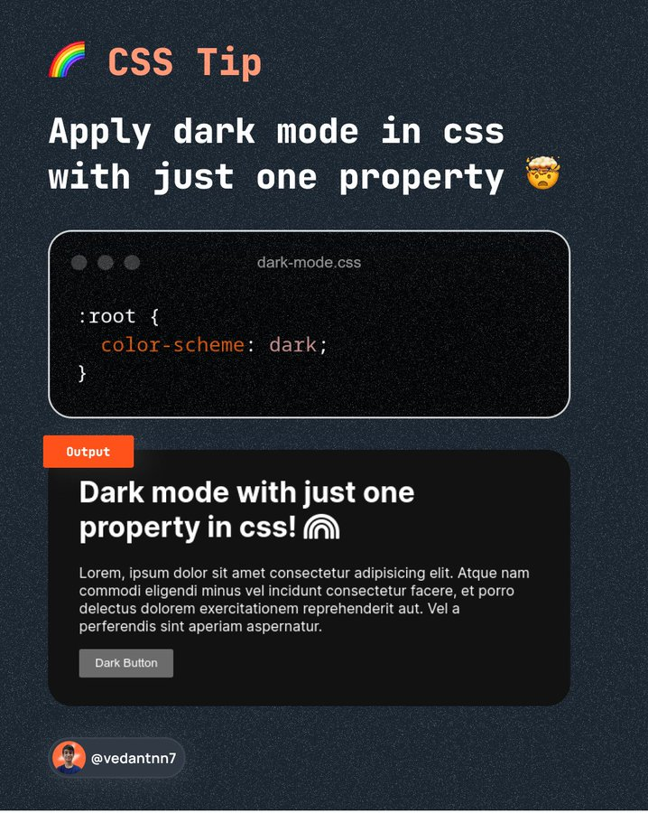

**Note : we can do that by java script : by**

**i) making class=”dark”**

**ii) in css: .dark:root{color-scheme:dark}**

**iii) add the dark class dynamicall in html tag :**

**eg: <html class=”dark”>**

3.Sibling selector: ~

.form-control:focus~.form-label{

*top*:-0.78rem;

*background-color*:gainsboro ;

        }

3.ii). particular class,id or element universal selector

#box*{

Color:green} /* it will going to give every text in box id green color */

iii) direct child selector

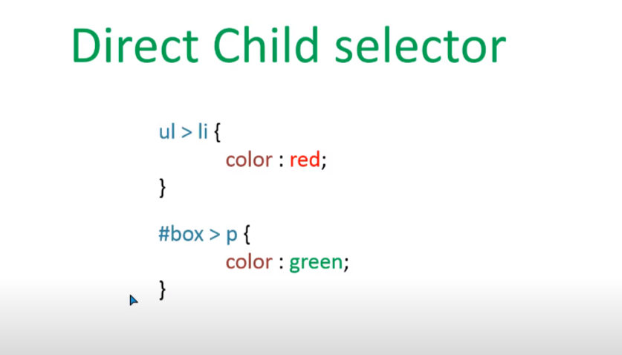

iv)immediate sibling selector

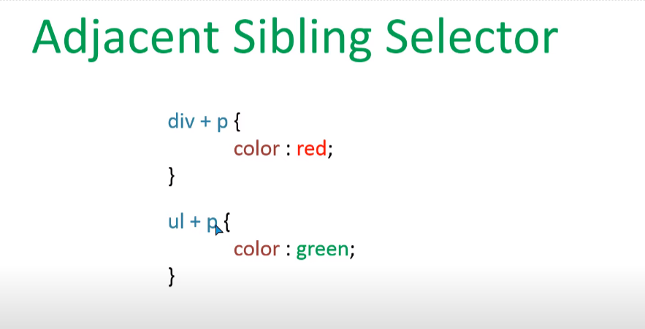

Note : it will going to select only the first sibling

V)sibling selector : it will going to select all the sibling with matching

Note : + and ~ will only going to target only the element that are after them not going to target the element that are before them

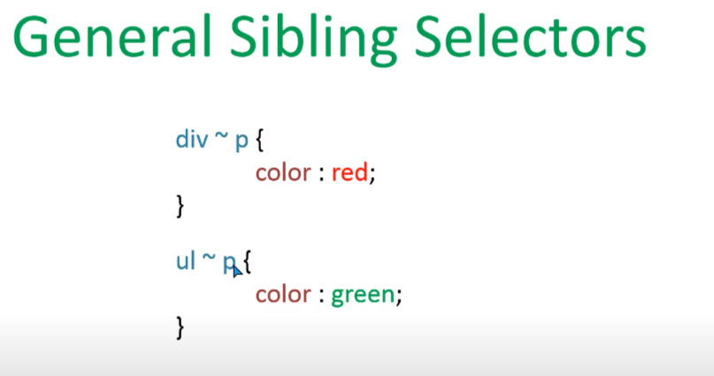

vi)attributries selector :

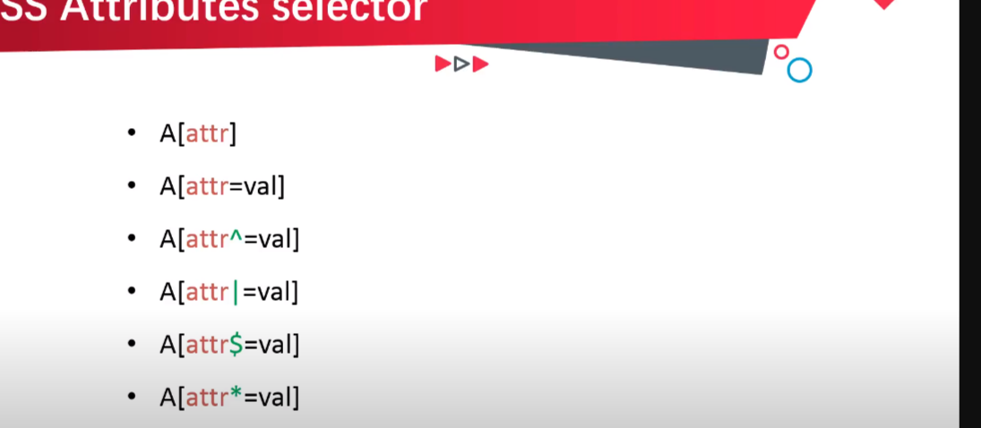

vii)before and after selector

note :we can not use before and after selector with image tag .

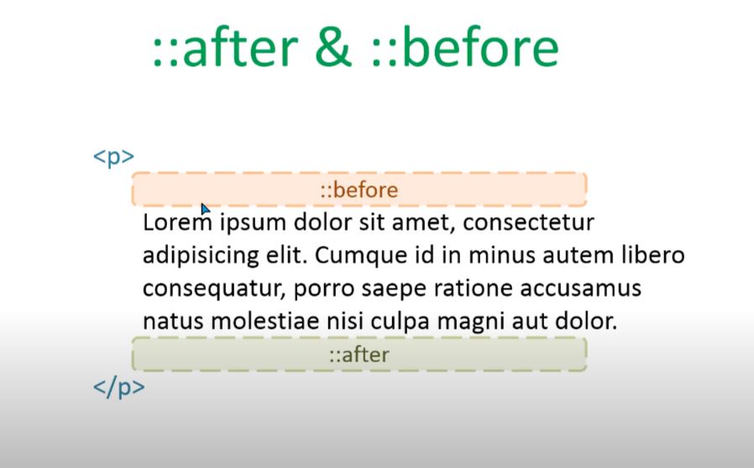

Vi)selection selecotor

4.

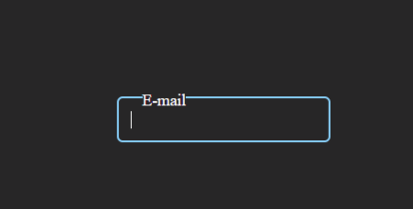

<!DOCTYPE html>

<html lang="en">

<head>

    <meta charset="UTF-8">

    <meta http-equiv="X-UA-Compatible" content="IE=edge">

    <meta name="viewport" content="width=device-width, initial-scale=1.0">

    <title>Document</title>

    <style>

        body {

*box-sizing*: border-box;

*min-height*: 90vh;

*display*: flex;

*justify-content*: center;

*align-items*: center;

*background-color*: rgb(39, 38, 39);

        }

        .form {

*position*: relative;

        }

        .form-control {

*border-radius*: 5px;

*background*: none;

*outline*: none;

*border*: 2px solid #fff;

*color*: #fff;

*padding*:10px;

        }

        .form-label {

*position*: absolute;

*top*: 0.6rem;

*left*: 1.4rem;

*cursor*: text;

*transition*: top 0.4s ease;

*color*: #fff;

        }

        .form-control:focus {

*border*: 2px rgb(138, 211, 255) solid;

        }

        .form-control:focus~.form-label,

        .form-control:not(:placeholder-shown)~.form-label

        {

*top*: -0.3rem;

*font-size*: 14px;

*background-color*: rgb(39, 38, 39);

        }

    </style>

</head>

<body>

    <div class="form">

        <input type="text" class="form-control" placeholder=" ">

        <label for="" class="form-label">E-mail</label>

    </div>

</body>

</html>

Note: do not forget to put empty place holder in input

Above video link :

<https://www.youtube.com/watch?v=CtYfbvWJlcM>

5.

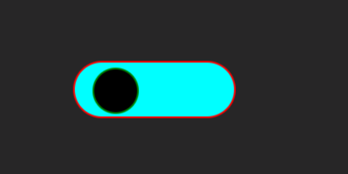

Link: <https://www.youtube.com/watch?v=qDyeXVgls1M>

<!DOCTYPE html>

<html lang="en">

<head>

    <meta charset="UTF-8">

    <meta http-equiv="X-UA-Compatible" content="IE=edge">

    <meta name="viewport" content="width=device-width, initial-scale=1.0">

    <title>Document</title>

    <style>

        body {

*box-sizing*: border-box;

*min-height*: 90vh;

*display*: flex;

*justify-content*: center;

*align-items*: center;

*background-color*: rgb(39, 38, 39);

        }

        input {

*display*: none;

        }

        label {

*display*: block;

*width*: 150px;

*height*: 50px;

*border*: 2px red solid;

*border-radius*: 50px;

*background*: #fff;

*position*: relative;

*cursor*: pointer;

        }

        label:before {

*content*: "";

*position*: absolute;

*top*:4px;

*right*:20px;

*display*: block;

*height*: 40px;

*width*: 40px;

*border*: 2px solid green;

*border-radius*: 50%;

*background*: #000;

*transition*: right 0.3s linear;

        }

        input:checked+label{

*background-color*: aqua;

        }

        input:checked+label:before{

*right*:90px;

        }

    </style>

</head>

<body>

    <div>

        <input type="checkbox" id="switch">

        <label for="switch"></label>

    </div>

</body>

</html>

6.form validate

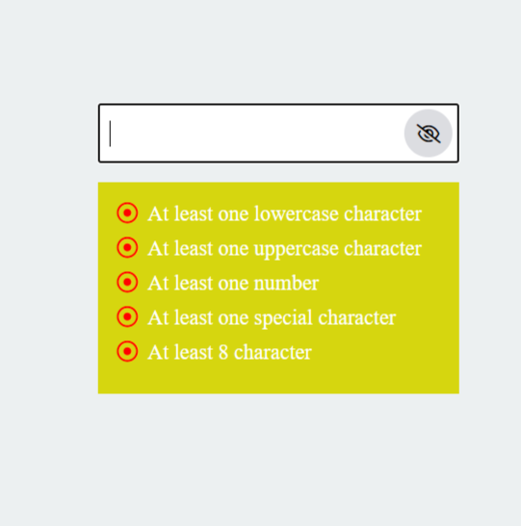

Video link : <https://www.youtube.com/watch?v=Hi8DVOaZ0Ug&t=615s>

Code :

<!DOCTYPE html>

<html lang="en">

<head>

    <meta charset="UTF-8">

    <meta http-equiv="X-UA-Compatible" content="IE=edge">

    <meta name="viewport" content="width=device-width, initial-scale=1.0">

    <title>Document</title>

    <link rel="stylesheet" href="https://cdnjs.cloudflare.com/ajax/libs/font-awesome/6.1.2/css/all.min.css" />

    <style>

        *{

*margin*: 0;

*padding*: 0;

*box-sizing*: border-box;

        }

        body{

*min-height*: 100vh;

*display*: flex;

*justify-content*: center;

*align-items*:center;

*flex-direction*: column;

*background-color*: #ecf0f1;

        }

        .inputbox{

*width*: 300px;

*height*: 50px;

*position*: relative;

        }

        .inputbox [type]{

*width*:100%;

*height*: 100%;

*font-size*: 1.2rem;

*padding-left*: 0.5rem;

*letter-spacing*: 2px;

        }

        .watch{

*position*: absolute;

*right*: 5px;

*top*:5px;

*width*: 40px;

*height*:40px;

*background-color*: #dcdde1;

*border-radius*: 50%;

*display*: flex;

*justify-content*: center;

*align-items*: center;

*cursor*: pointer;

*transition*:0.3s ease;

        }

        .watch::before{

*content*:'\f06e';

*font-family*: fontAwesome;

        }

        .watch.hide::before{

*content*: '\f070';

        }

        .validation{

*width*:300px;

*margin-top*: 1rem;

*padding*: 1rem;

*background-color*: rgb(214, 214, 15);

        }

        .validation ul{

*list-style*: none;

        }

        .validation ul li{

*font-size*: 1.1rem;

*margin-bottom*: 0.5rem;

*color*:#fff;

        }

        .validation ul::last-child{

*margin-bottom*: none;

        }

        .validation ul li::before{

*content*:'\f192';

*font-family*: fontAwesome;

*margin-right*: 0.5rem;

*color*:red;

        }

        .validation ul li.valid::before{

*content*:'\f00c';

*color*: rgb(34, 221, 34);

        }

    </style>

</head>

<body>

    <div class="inputbox">

        <input type="password" id="form" onkeyup="checkpassword(this.value)">

        <span class="watch"></span>

    </div>

    <div class="validation">

        <ul>

            <li id="lower">At least one lowercase character</li>

            <li id="upper">At least one uppercase character</li>

            <li id="number">At least one number</li>

            <li id="special">At least one special character</li>

            <li id="char-no">At least 8 character</li>

        </ul>

    </div>

    <script>

*let* inputSelect=document.getElementById('form');

*let* watchbox=document.querySelector('.watch');

        watchbox.addEventListener('click',()*=>*{

            if(inputSelect.getAttribute('type')=='password'){

                inputSelect.setAttribute('type','text');

                watchbox.classList.add('hide');

            }

            else{

                inputSelect.setAttribute('type','password');

                watchbox.classList.remove('hide');

            }

        });

*let* lowerId=document.getElementById('lower');

*let* upperId=document.getElementById('upper');

*let* numberId=document.getElementById('number');

*let* specialId=document.getElementById('special');

*let* char_noId=document.getElementById('char-no');

*function* checkpassword(*data*){

*let* lower=new *RegExp*('(?=.*[a-z])');

*let* upper=new *RegExp*('(?=.*[A-Z])');

*let* number=new *RegExp*('(?=.*[0-9])');

*let* special=new *RegExp*('(?=.*[!@#\$%\^&\*])');

*let* charno=new *RegExp*('(?=.{8,})')

            if(lower.test(*data*)){

                lowerId.classList.add('valid');

            }

            else{

                lowerId.classList.remove('valid');

            }

            if(upper.test(*data*)){

                upperId.classList.add('valid');

            }

            else{

                upperId.classList.remove('valid');

            }

            if(number.test(*data*)){

                numberId.classList.add('valid');

            }

            else{

                numberId.classList.remove('valid');

            }

            if(special.test(*data*)){

                specialId.classList.add('valid');

            }

            else{

                specialId.classList.remove('valid');

            }

            if(charno.test(*data*)){

                char_noId.classList.add('valid');

            }

            else{

                char_noId.classList.remove('valid');

            }

        }

    </script>

</body>

</html>

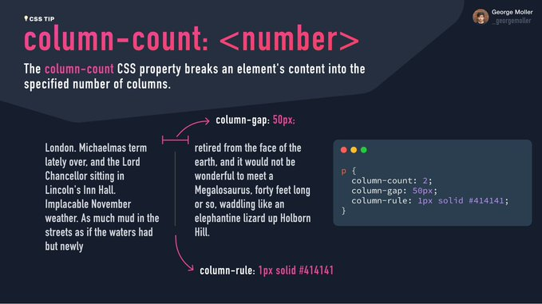

For color : https://flatuicolors.com/

Note: for background image : pixcel.com

1. Font awesome link : <link rel="stylesheet" href="https://cdnjs.cloudflare.com/ajax/libs/font-awesome/4.7.0/css/font-awesome.min.css">
2. Better font aswome link :

<script src="https://kit.fontawesome.com/d0ce3eb2d9.js" crossorigin="anonymous"></script>

Just import from the website : <https://fontawesome.com/v4/icons/>

HOW TO CREATE A WEBSITE :

PROFREEHOST -> REGISTER -> Create a new account -> worldpress

1. HOW to keep container at the center of the screen

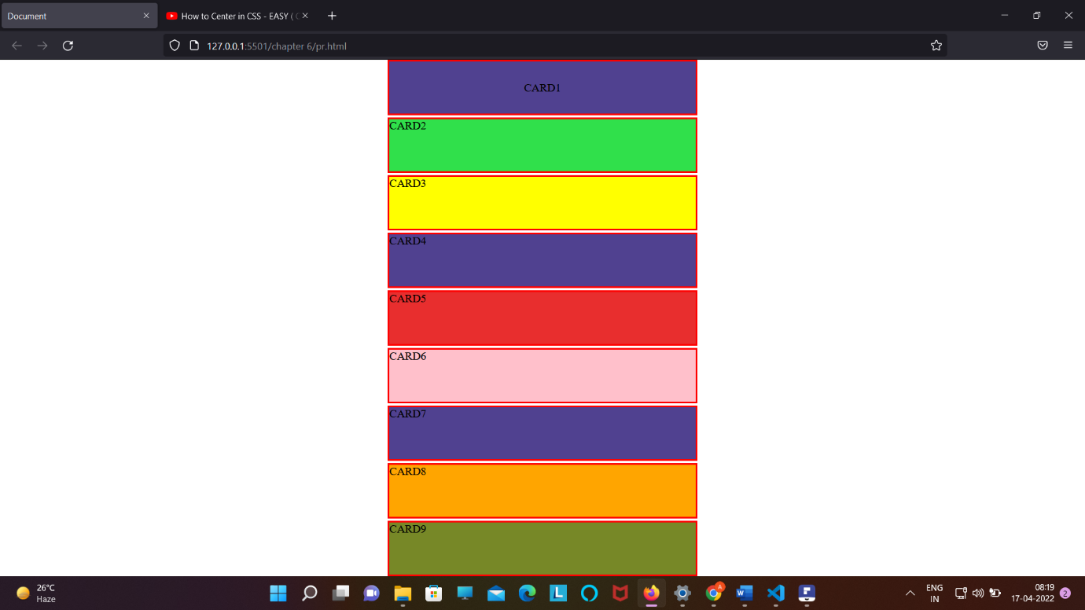

Margin : auto ;

2 . How to keep the text in the container at the center from top/right/bottom/left;

Display : flex;

Align-content : center;

Justify-content : center ;

3. justify-content :

Link : <https://www.w3schools.com/cssref/css3_pr_justify-content.asp>

3 . in order to not filling anything box :

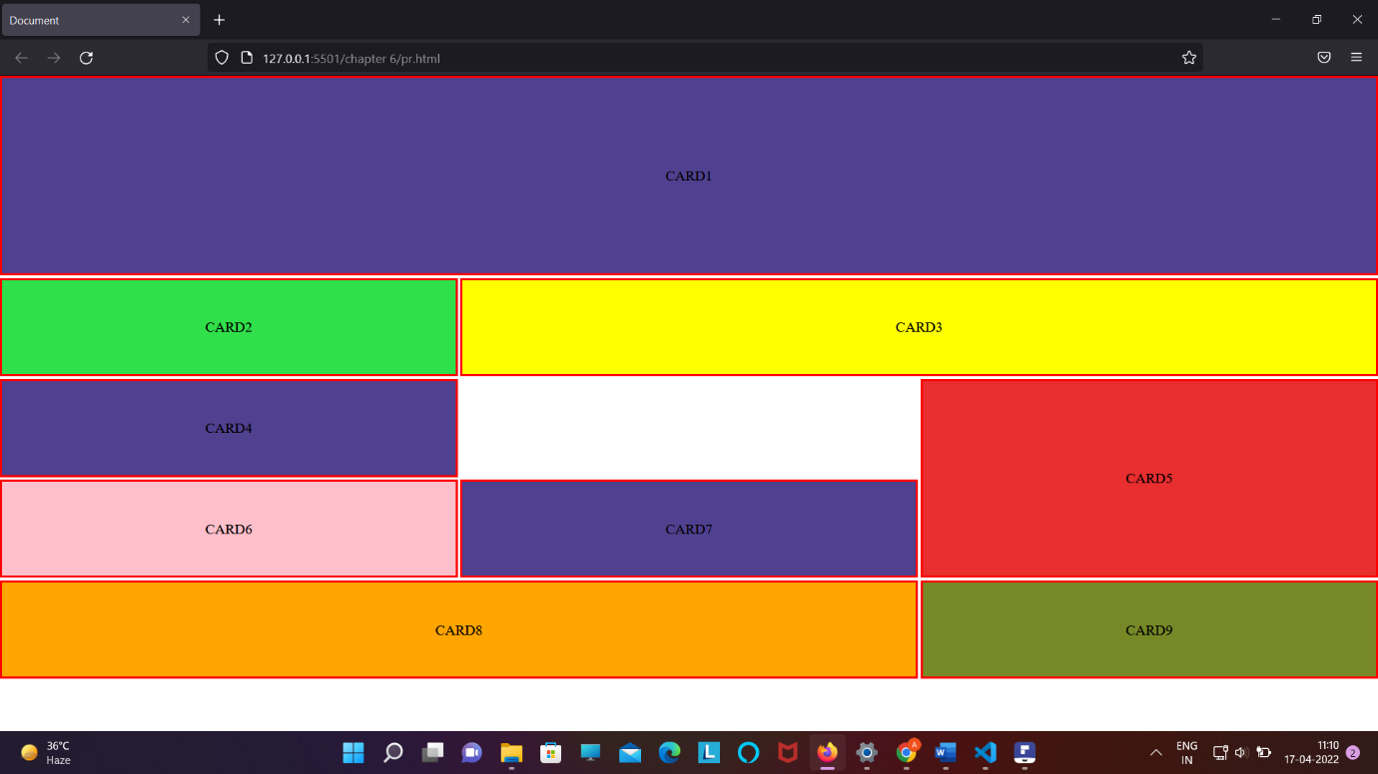

We need to use :

Display : grid;

Grid-template-area:

“ card1 . card2 “ /* bindi is ued to do such thing * /

4. top put any back ground image to full the screen or container to zooming image by keeping image at the center

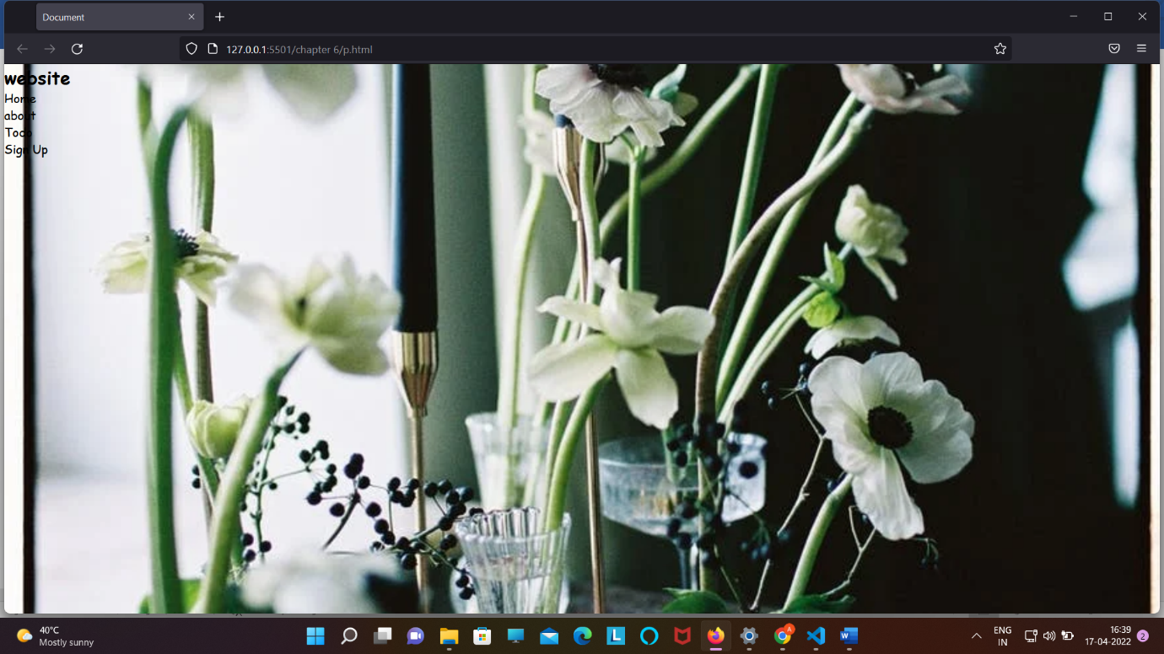

Step 1 : keep the image at the center (background-postion : center ;)

Step 2 : background-size : cover :

.headder{

*min-height*: 100vh;

*background*: url("https://images.pexels.com/photos/11677398/pexels-photo-11677398.jpeg?auto=compress&cs=tinysrgb&dpr=2&h=650&w=940") no-repeat center;

*background-size*: cover;

*color*: black;

height : 110vh;

}

5 . DISPLAY PROPERTY :

A . display: inline ;

B. display : block ;

C . display: inline-block ; // it will make the item of the container to display in line but it will a create a block for each element

D . display: inline-flex : /* it will make the all item of the container to display in line and it will not going to create any block ;

There is only one main difference between the **inline-block** and **inline-flex**:   
**inline-block:** Create specific block for each element under its section maintain the structure of each element.   
**inline-flex:** Does not reserved any specific space in normal form.

6. another way to making nav bar like ( SABKO CENTER MAI LAKAR BIKHARNA )

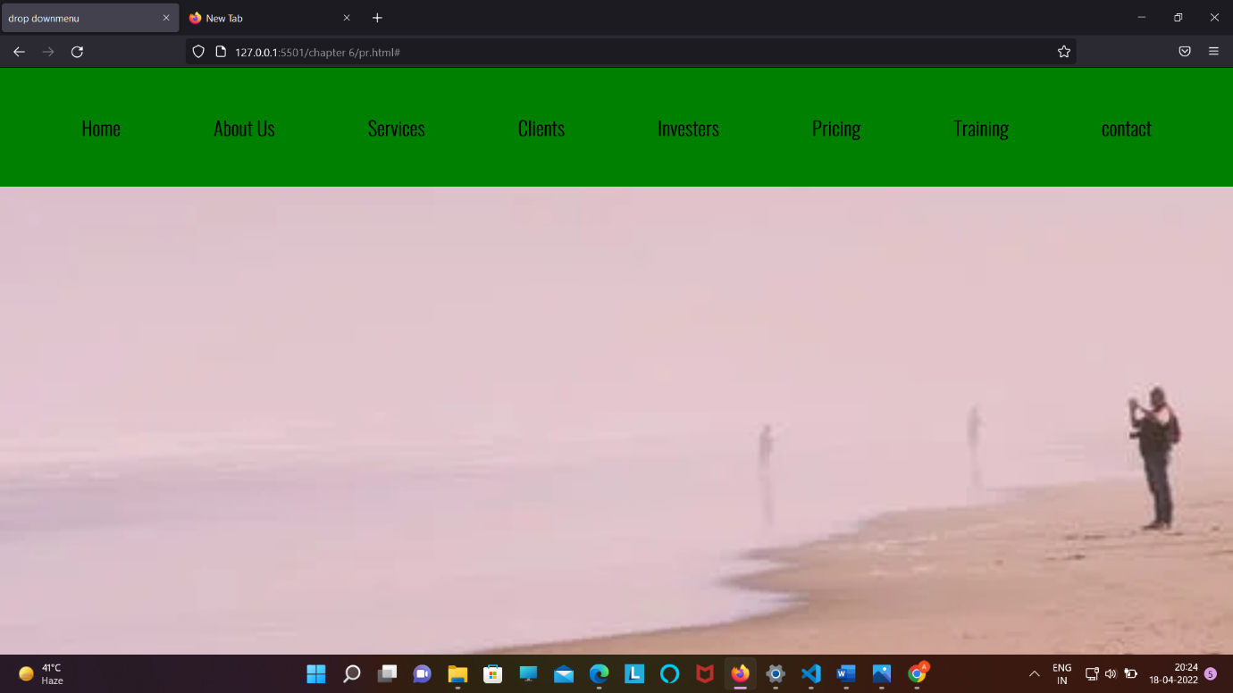

<!DOCTYPE html>

<html lang="en">

<head>

    <meta charset="UTF-8">

    <meta http-equiv="X-UA-Compatible" content="IE=edge">

    <meta name="viewport" content="width=device-width, initial-scale=1.0">

    <title>drop downmenu</title>

    <link rel="stylesheet" href="p.css">

</head>

<body>

    <header>

        <nav>

            <ul class="nav_bar">

                <li><a href="#">Home</a></li>

                <li><a href="#">About Us</a></li>

                <li><a href="#">Services</a></li>

                <li><a href="#">Clients</a></li>

                <li><a href="#">Investers</a></li>

                <li><a href="#">Pricing</a></li>

                <li><a href="#">Training</a></li>

                <li><a href="#">contact</a></li>

            </ul>

        </nav>

    </header>

</body>

</html>

.nav_bar{

Text-align :center;

}

.nav_bar li{

Display : inline-flex;

Margin :1rem;

Padding :1rem;

}

6 . button degin code :

.btn{

*display*: inline-block;

*border*: none;

*outline*: none;

*cursor*: pointer;

}

.btn-headline{

*padding*: 1rem 2rem;

*margin*: top 1rem;

*font-weight*: 600;

}

7. To place any thing wrt to parents then :

First : we give position : relative : /* to parents */

Second : we give position : absolute ; /* to element which we want to place * / and measurement will be in percentage for element which we want to place .

Parent :

.header {

*position*: relative;

element :

.wirteup {

*text-align*: center;

*position*: absolute;

*top*: 50%;

*left*: 50%;

*transform*: translate(-50%, -50%);

}

8 . setting container in every item we are goning to get

.container {

*max-width*: 1200px;

*margin*: auto;

*width*: 90%;

}

9 . to make input attribute in single line :

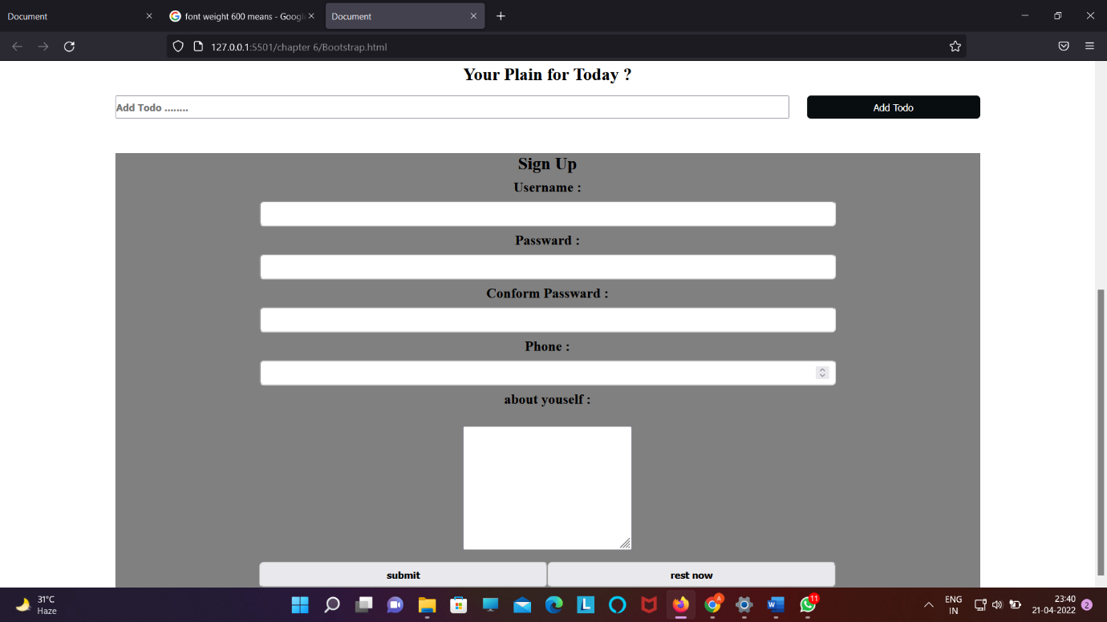

Lable{

Display:block;

}

Input{

Display : block;

}

.section-signup label,

input {

*display*: block;

}

When ever we are writing para remember to use :

Line-height:

Letter-spacing:

<br>

*line-height*: 1.5rem;

*letter-spacing*: 0.1rem;

*font-family*: Arial;

During making nav bar or button try to use :to bring animation

*transition*: 0.3s ease-in;

.section-btn button:hover{

*background-color*: white;

*color*: orange;

}

* We can control the width and height of image by :
* <img src="Madhubala1957.png" height=500px" width="1200px" alt="...">
* USE OF :

1 . :firstchild

2.lastchild

3. nth-child(write child no)

4. :nth-of-type()

🡺 Use of z-index :

Note z index will only going to work when we have given position : relative / absolute / fixed / sticky

Use of Opacity :

Note – it can take value between 0 to 1;

0 means : note visible ;

1 means : fully visible ;

Use of overflow :

Link : <https://www.w3schools.com/css/css_overflow.asp>

Note :

If we want to align any box into top , bottom , left and right if we are unable to do with text-align the

We can use :

Position : relative / absolute;

Top / bottom / left / right = 0;

Box-shadow :horizontal-offset ,vertical-offset , blur , shadow-spread ,color ;

Link-to stdy : <https://www.w3schools.com/cssref/css3_pr_box-shadow.asp>

Agar kisi ko center mail lana(from all direction top,right,bottom,left ) hai too :

Step-> ek div banayenge div.container

Step 2 -> iske under jisko center mail ana hai wo likhege div.items

.css :

.container{ display: flex; justify-content :center ; align-items:center;

}

.items{ text-align: center ; max-width :80%;

}

** sticky nav_bar tutorial : check project

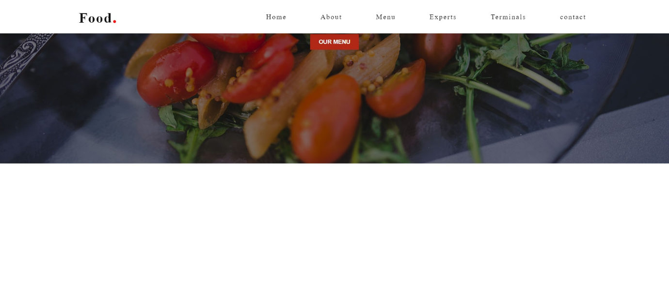

*const* sticy_header = () *=>* {

*const* container = document.querySelector(".container");

  window.addEventListener("scroll", () *=>* {

    container.classList.toggle("sticky", window.scrollY > 0);

  });

};

sticy_header();

css : .sticky{

*background*: #fff;

*padding*: 15px 15px ;

*box-shadow*: 0 5px 20px rgba(0,0,0,0.05);

}

.sticky .logo{

*color*:#111;

}

.sticky .nav-items a{

*color*: #111;

}

*** NOTE : IF WE WANT TO KEEP SPACE ALL ARROUND ANY THING IN THE CONTAINER That can be done by:

Applying :

.container{

Padding : 100px;

}

Eg : in about section : section{padding :100px } ;

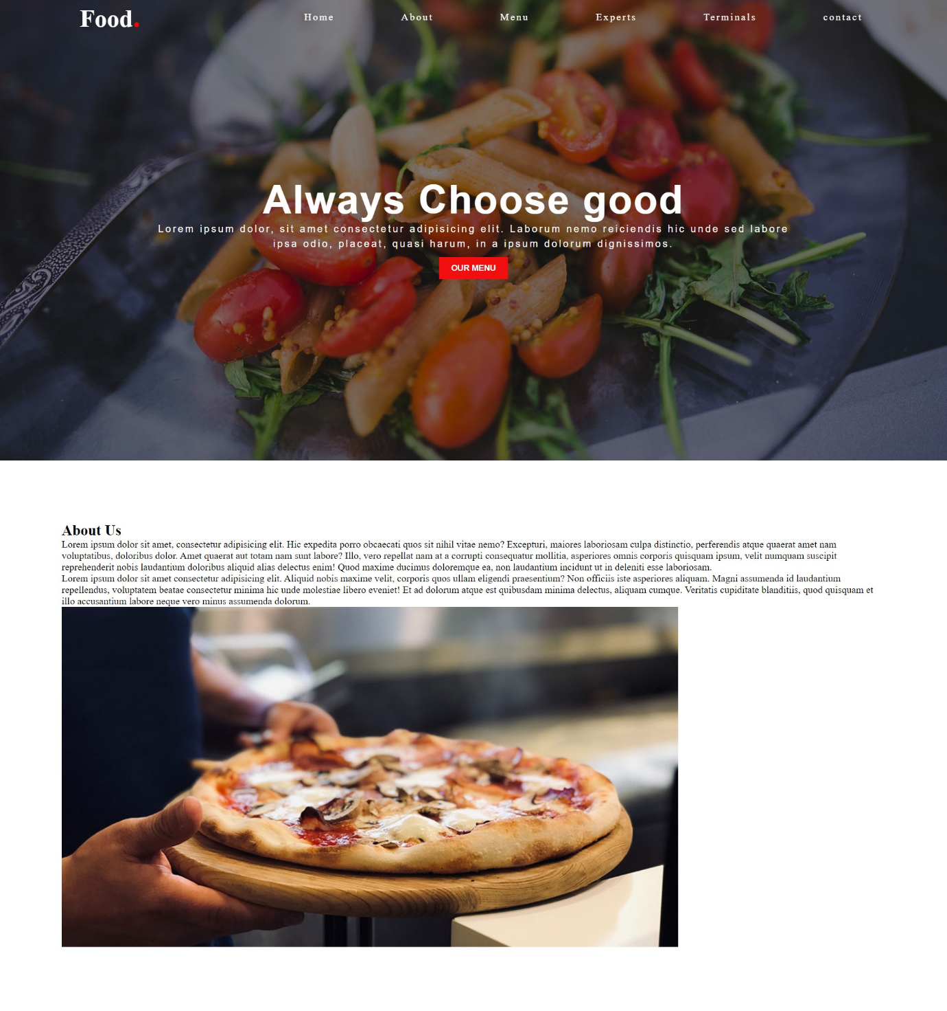

To put any thing at the center of the box:

Position : absolute ;

top : 50%;

left : 50%;

transform :translate(-50%,-50% ) ;